Heriot Watt University
School of Mathematics and Computer Science
MEng Software Engineering

Higher Education Study-Planner


Deliverable 1: Final Year Dissertation
Matthew Frankland
SUPERVISOR: Frank Broz

Declaration

I, Matthew Frankland, confirm that this work submitted for assessment is my own and is expressed in my own words. Any uses made within it of the work of other authors in any form (e.g. ideas, equations, figures, text, tables, programs) are properly acknowledged at any point of their use. A list of the references employed is included.

Signed: Matthew Frankland
Date: 08/11/2019

Abstract

Students’ learning in higher education is currently affected by a lack of mobile applications for planning and tracking their academic life. Resources that are available are hindered by a number of critical flaws including no mobile optimisation, badly designed UXs and out of date architectures. The aim of this project is to develop a mobile (iOS and Android) application and web-based portal that fixes these persisting issues and introduces some new unique features.

Each component of the mobile application will have an intuitive design and UX. The components of the mobile application will include file sharing boards, notification reminders, shared calendars, locally stored timetables, space to take lecture notes and instant messaging support.

The online portal will allow lecturers to connect with students. Lecturers will be able to view publicly available details on students, send out notifications, respond to messages, and add new events to shared calendars.

Abbreviations

UX – User Experience
UI – User Interface
PNS - Push Notification Service
PHP – Hypertext Preprocessor
HTTP – Hypertext Transfer Protocol
IPC – Inter Process Communication
SQL – Structured Querying Language
HTML – Hypertext Manipulation Language
CSS – Cascading Style Sheet
FSR – Functional System Requirement
NFSR – Non-Functional System Requirements;
OS – Operating System
MVC – Model View Controller

Table of Contents
Declaration 1
Abstract 2
Abbreviations 3
1. Introduction, Aims and Objectives 6
1.1 Introduction 6
1.2 Aims 6
1.3 Objectives 7
2. Background 8
2.1 Mobile Applications in Higher Education 8
2.1.1 Device Ownership Survey (Chen et al., 2013) 8
2.1.2 Learning Management System 10
2.2 Mobile Technology Review 10
2.2.1 Software 11
2.2.2 Existing Applications 14
3. Requirements Analysis 16
3.1 System Requirements Analysis 16
3.1.1 Use Cases 18
3.2 User Requirements Analysis 19
3.3 Challenges 19
3.3.1 Access to University Database 19
3.3.2 Storing Student Information 20
3.3.3 Compatibility with all Smartphone Types 21
4. Design 22
4.1 MVC 22
4.2 Initial Sketch of System Architecture 23
4.3 Architecture Languages 24
4.3.1 Mobile Implementation 24
4.3.2 Website Implementation 24
5. Evaluation Strategy 25
5.1 First Usability Evaluation 25
5.2 Second Usability Evaluation 27
5.2.1 Automated Unit Testing 28
6. Project Management 29
6.1 Timetable 29
6.2 Gannt Chart 30
6.3 Analysis of Risks 30
6.4 Considerations of Professional, Legal, Ethical, and Social Issues 34
A. References 35
B. Figures 39
C. Appendix 40
1. Textual Use Case Descriptions 40

1. Introduction, Aims and Objectives

1.1 Introduction

Students’ learning in higher education is currently affected by a lack of mobile applications for planning and tracking their academic life. Resources that are available are hindered by a number of critical flaws including no mobile optimisation, badly designed User Experiences and out of date architectures. The aim of this project is to develop a mobile (iOS and Android) application and web-based portal that fixes these persisting issues and introduces some new unique features.

Nearly all students and lecturers work asynchronously across multiple different areas of study. Therefore, it is imperative that any system for recording academic work, checking upcoming events, and communicating with colleagues be fast, simple, and easy to access. A high-level objective of this project is to meet these three criteria. This will be achieved by optimising the application’s code for the local web browser or mobile device.

Another high-level objective of this project will be to design a contemporary UI. Evidence has shown that a well-designed User Interface can result in productivity, accessibility and user retention all increasing (Harte et al., 2017). Market data and regular prototype feedback will be gathered to inform design decisions and achieve this objective.

1.2 Aims

This project’s aim is to implement and deploy an innovative mobile study planner (iOS and Android) which works in tandem with an online portal for lecturers. Each component of the mobile application will have an intuitive design and UX. The components of the mobile application will include file sharing boards, notification reminders, shared calendars, locally stored timetables, space to take lecture notes and instant messaging support. The online portal will allow lecturers to connect with students. Lecturers will be able to view publicly available details on students, send out notifications, respond to messages, and add new events to shared calendars.

1.3 Objectives

The objectives of this project are to:
- Review literature material on how students use mobile technologies to achieve academic success
- Develop a mobile application for the study planner which includes an intuitive UI font-end; an intermediary controller for handling data; and a database
- Develop a website which acts as a lecturer portal for the study planner and includes a front-end view with lecturer specific functions; and integration into the existing intermediary controller
- Run a user-cantered iterative usability evaluation. The first evaluation will be a small, closed study aimed at identifying areas for improvement in both applications and will involve a select number of lecturers and students. The second evaluation will be a public UX study via TestFlight and Android Beta Testing to gain a deeper insight into the opinions of potential end users
- Deploy both applications onto a public domain or mobile application store and advertise the public launch of these applications to higher education institutes

2. Background

2.1 Mobile Applications in Higher Education

Mobile devices are quickly becoming vital tools for achieving academic success. The reason for this is that they provide simple methods for communicating with peers and accessing information. This has presented new opportunities for developing classroom learning through utilising these mobile devices as knowledge bases, management tools, and means of storing data (Peters, 2005).

With the importance of mobile devices in education getting ever higher, it has become necessary to understand what devices students own and how student’s use these devices. A survey was conducted to collate this data (Dahlstrom et al., 2013) and it found that the majority of students in higher education own some form of mobile device with many using these devices for academic work. However, the frequency of mobile technologies being used within the classroom was found to be dependent upon lecturer’s personal attitudes towards these devices. When the lecturer’s attitude towards mobile devices in the classroom was positive, 49% of those surveyed said they were more likely to proactively engage with their course (Seilhamer et al., 2013).

A further survey on the same topic as the survey above was done to help further mobile device adoption within the classroom. The following section will discuss two of the three areas of this survey’s investigation including devices and digital skill levels.

2.1.1 Device Ownership Survey (Chen et al., 2013)

The following data on device ownership among students in higher education was gathered by Educause through a survey conducted at the University of Central Florida in 2012 (Figure 1 (Chen et al., 2013)). 91% of respondents said they particularly favoured owning a smartphone during higher education. Tablet devices had a much lower favourability rating among student (37%) however this figure was found to have been impacted by age and education level. If the survey results were narrowed to just graduates or older students, then favourability levels for tablet devices increased.
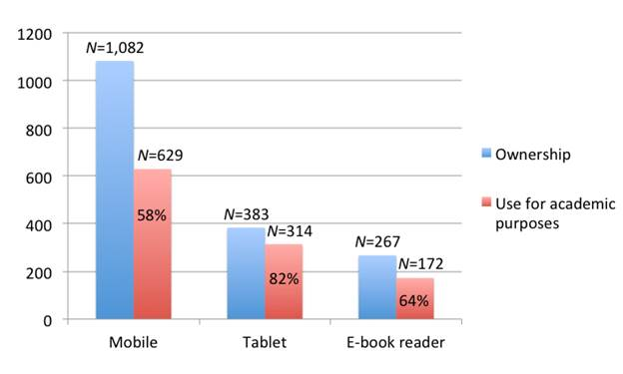
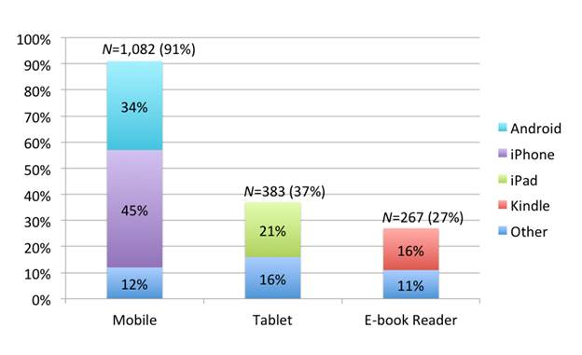
Figure 2. Comparing ownership and use for academic purposes (N=1,082), Chen et al, 2013
Figure 1 Device Ownership (N=1,082), Chen et al, 2013

The survey went on to ask whether students used their devices for academic purposes. As Figure 2 (Chen et al., 2013) shows, 58% of respondents who said they owned a smartphone said that they did use their device for academic purposes versus 82% for respondents who said they owned a tablet. Students who used a device for academic purposes stated that one of their primary uses was interaction with a Learning Management System (Section 2.1.2). Students age, ethnicity, academic year, grade point average and gender all affected the results. The key findings being:
- The age of a student had a small impact upon whether they use their mobile device for academic purposes.
- Male students use their devices for academic purposes more than female students.
- No significant factor could be drawn for tablet devices as their use for academic purposes was high.
- There was negative correlation between mobile device ownership and grade point average. The study hypothesised that those with a lower academic rating are more drawn to their mobile phones as a means of distraction from hard study. It did not however draw any fixed conclusions as to why this correlation occurred.

2.1.2 Learning Management System

The applications proposed by this project share some similarities with Learning Management Systems. A learning management system is a system that assists in the management and delivery of educational based learning (Martin, 2008) and is run on the devices discussed in Section 2.1.1. Tools on these systems normally include the ability to run tests, set assignments, issue announcements and marks, and share files. An example of such a system is Blackboard which is one of the leading stakeholders in these systems in Europe and North America (Machado, Tao, 2007). Past studies have compared and contrasted such systems and found that the key features that measure success for these products are “usability, availability, security, stability, interoperability, and scalability” (Hall, 2003).

Core features of the exemplar learning management system Blackboard can be regarded as “Assignment”; “Gradebook”; “Course Documents”; “Announcement”; “Communication”; “Digital Dropbox”; “Discussion Board”; “Group Pages”; and “Virtual Classroom” (Martin, 2008). Of these features Blackboard has consistently been ranked among students and lecturers as achieving the first three successfully. Students and lecturers have been critical about the effectiveness of Blackboard in these final six areas however (Green et al., 2012) (Bradford et al., 2007). This projects system is proposing a solution to these categories with the study planner applications as Blackboard is currently failing students and lecturers in these areas. More details on what core features will be the same and what core features will differ from Blackboard will be discussed in Section 2.2.2.

2.2 Mobile Technology Review

Now that more information has been gathered about how students use their mobile devices, the following section will discuss some of the key technologies and computing concepts needed to create a mobile application.

2.2.1 Software

2.2.1.1 Third-Party Libraries

Third-party libraries are reusable software modules which are created and maintained by a single developer or development group. Third-party libraries have a number of uses such as connecting your app to social media sites, displaying advertisements that form a revenue stream, and adding the ability to extract analytical information. Third-party libraries can also extend core functionality and make development faster and cleaner (Ma et al., 2016).

Using third-party libraries has many potential advantages, including decreasing development time because of code reuse and increasing efficiency on executed tasks. Disadvantages of third-party libraries are that they often have little technical support and can cause security flaws in your application if its code contains vulnerabilities (Raemaekers et al., 2012) (Haefliger et al., 2008).

An example of a well design third-party library that will be good to use in this project is react-native-firebase (invertase, 2019). This is a third-party library which connects an application to all Firebase services. This widely used third-party library would be useful for gathering analytical information during the usability studies. It is also is highly reviewed, well-maintained, and well-documented.

2.2.1.2 Push Notification Service

Mobile push notification services enable developers to send notification data to end user devices. The following section the architecture behind these systems.

Data dissemination requests can fall into one of two categories, either a pull or push request. A pull request is a user made request for a particular piece of data from an external server. The server handles this request and sends the data back to the requester. A push request occurs without an explicit user request. A push request is instead initiated by an external server, usually through a service, which pushes the data to a user device. A PNS is a push request service that sends data to a user’s device in the form of notifications (Guo et al., 2013).

The main flaw in push requests is that data has the potential to be pushed to a device without the user’s permission. A fix for this is to implement a push request system using tokens. The token model allows users to preapprove notification servers before any data is sent to their device. This model works by a device requesting a unique token from the notification server upon first connection. The device stores this token in the application server and thereafter a copy of this token is sent with every notification message. The notification server can send the notification to the user’s device if the notification server has the token in its approved list. See Figure 3 (Haefliger, 2008).
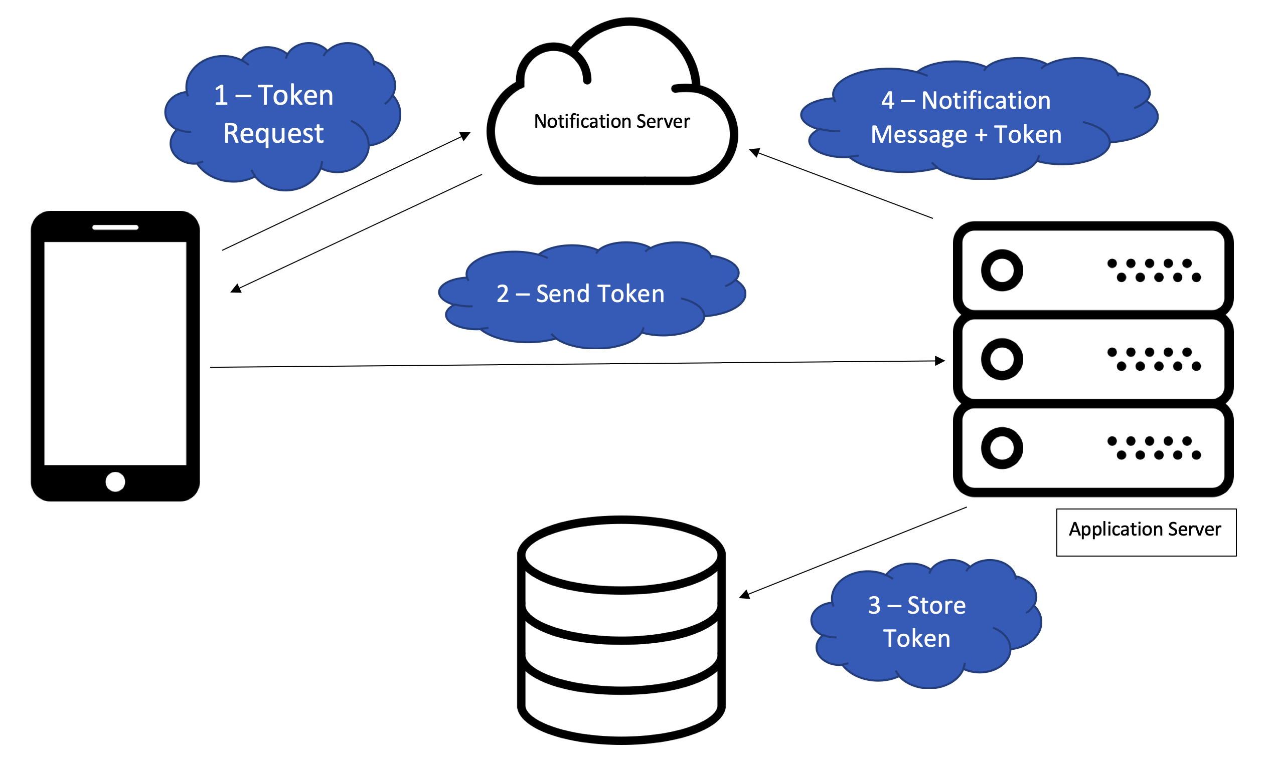
Figure 3: Token System for Push Requests
Push requests have three main types: blanket push, filtered push, and subscribe/publish push. Blanket push is a method for pushing a regular message to a device without the need for device filtering. There are many free services that offer blanket push requests however they come with a high bandwidth load on the application server and customization options are limited (Guo et al., 2013).

Filtered push is a method for pushing a message to a filtered device list. This type of push request requires more administration by the user but does allow for higher degree of customization and uses less bandwidth than blanket push requests (Guo et al., 2013).

A subscribe/publish push allows users to set preferences on their device on what notifications they want to receive. This is combined with external data on the application server to form classification groups. This type of push request uses less bandwidth on the application server than filtered push, but the scalability of these requests is usually untested before application rollout (Guo et al., 2013).

2.2.1.3 Secure Storage

As society has increasingly begun to use mobile devices for security sensitive tasks, like storing passwords and banking information, it has become imperative that mobile device data is stored securely. REACT-Native can use a number of security mechanisms that are available to do this: (Cooijmans et al., 2014)

- Android KeyStore
Android KeyStore is a method of storage that is unique to the Android operating system. It uses Inter Process Connection technology to communicate with a service called KeyStore which stores cryptographic keys in a separate software container. When data is in the KeyStore it can be used for cryptographic operations, but it cannot be exported back out of the KeyStore. This means that a user entered password cannot be used to encrypt any keys.

- Keychain
Keychain is a secure method of storage unique to the iOS operating system. The keychain API allows an application to store small pieces of data such cryptographic keys and certificates for secure communication.

Keychain or KeyStore can be accessed in REACT-Native through use of a third-party library, for example react-native-keychain (oblador, 2019).

2.2.1.4 Limitations

Smartphones have a lower screen resolution compared to tablet devices. This limits the UX when a large amount of data is displayed at one time. Problems may occur if, for example, development is only carried out on tablet devices. The result would be users performing a lot of scrolling in order to view the data that was available on the screen. A better method of presenting data, that overcomes this limitation, is to structure data in a controller based hierarchical format (Gong, 2004).

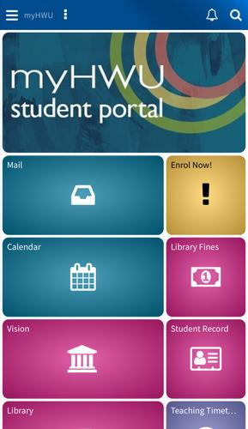
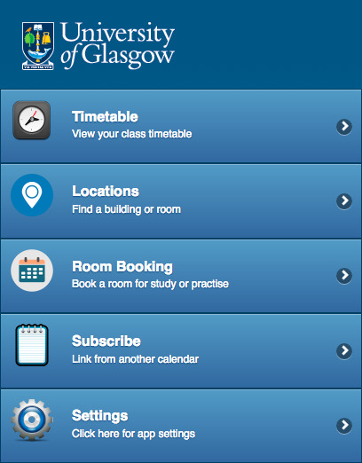
Mobile devices are usually owned by only one person and therefore are personal to each individual. This fact is normally reflected in the program filesystem and could cause problems if, for example, folder names have been customised. Device users may also have differing skill and therefore some services that a developer would expect to be running may not be because they have not been set up by the user (Gong, 2004). It would therefore be best in this project’s applications to stick to core libraries as much as possible.
Figure 5: myHWU (Collabro, 2017)
Figure 4: Timetable & Room Finder (University of Glasgow, 2019)

2.2.2 Existing Applications

Many higher educational institutions have created mobile applications or mobile friendly versions of their websites using the above technologies to try and take advantage of research into students’ mobile practices. Two such examples are ‘myHWU’ (Collabro, 2017) by Heriot-Watt University and ‘Timetable & Room Finder’ (University of Glasgow, 2019) by Glasgow University. These apps offer useful tools to students when they are not in classes. This often includes information on shops, study locations, event timetables and public transport. All of these applications do not offer any, or very limited, benefits to students for during their academic learning. This project will seek to implement features that are specifically for academic learning such as file sharing boards, shared calendars and locally stored timetables. As figures 5 and 6 shows, both ‘myHWU’ (Collabro, 2017) and ‘Timetable & Room Finder’ (University of Glasgow, 2019) have bland UIs. ‘myHWU’ has a lot of functionality which makes the UI seem busy and cluttered. This can turn users away when they are looking for something specific, such as their student record. A good aspect of ‘myHWU’ however was its use of colour, font and font weight to control the hierarchy of elements that are on screen compared with ‘Timetable & Room Finder’ which relies heavily on the font size to control the hierarchy of elements.

Mobile devices also offer some of the functionality that will be built into this project such as shared calendars through a local Android or iOS calendar app. Shared calendars through the local Android or iOS calendar app is not however tailored towards an educational environment. Many features that would be beneficial in this environment, such as individual permissions, are therefore missing. This project would aim to fix these flaws by tailoring all features, including shared calendars, for the academic environment that the app is eventually intended for.

A learning management system called ‘Blackboard’ offers some similar functionality to this project (Section 2.1.2). Blackboard offers simple board sharing tools including tools to share files, run tests, submit documents and send out notifications. The major advantage of Blackboard is that it is simple and easy to access through any web browser. It also requires little technical training. Due to its age Blackboard does not incorporate newer new web/browser technologies into its system, has an outdated UI and older design structure. Blackboards cloud services are also slow and a burden to develop on because of their outdated architectures. This project will aim to gather some of the market share of Blackboard through using modern up to date technologies to enhance similar functionality between the two systems.

3. Requirements Analysis

3.1 System Requirements Analysis

The following system requirements, which are derived from the aims and objectives of this project (Section 1.2 and 1.3), are essential if the mobile application and web-based portal are to function correctly. A matrix of system requirements is laid out below.
 | Requirement | Priority
FSR-1 | The System Must Allow Users to Login and Register | M
FSR-1.1 | The Mobile Application Must Allow Student’s to Login and Register | M
FSR-1.2 | The Online Portal Must Allow Lecturer’s to Login and Register | M
FSR-1.3 | The System Must Allow Users to Reset Their Password if They Forget It | M
FSR-1.4 | The System Should Be Able to Assign Student’s to Their Academic Class Groups After Students Login to Retrieve Their Timetable | S
FSR-2 | The System Must Request Consent to Save Any User Entered Data | M
FSR-3 | The System Must Generate User Profile’s on Registration | M
FSR-3.1 | The System Should Allow User’s to Add Extra Details to their User Account | S
FSR-3.2 | The System Must Allow User’s to Set Privacy Controls on Their Profile Details | M
FSR-3.3 | The System Could Allow User’s to Set a Profile Picture | C
FSR-3.4 | The System Should Allow Lecturer’s Access to Public Student Details | S
FSR-4 | The System Must Be Able to Access Student’s Teaching Timetables When Requested | M
FSR-4.1 | The System Could Be Able to Save Student’s Timetables on Local Mobile Storage | C
FSR-5 | The System Must Implement Shared Calendars | M
FSR-5.1 | The System Must Allow Lecturer’s to Update Course Shared Calendars | M
FSR-5.2 | The System Could Incorporate Shared Event Calendars for Student Union and University Main Office | C
FSR-6 | The System Must Have File Sharing Boards | M
FSR-6.1 | The System Should Have Sub-Group Student Boards | S
FSR-6.2 | The System Might Offer Previews of Files | W
FSR-6.3 | The System Could Have Subgroup Boards for the Student Union and University Main Office | C
FSR-7 | The System Must Give System State Notifications | M
FSR-7.1 | Lecturer’s Must Be Able to Push Notifications to Select Users | M
FSR-7.2 | University Office Staff Should Be Able to Push Notifications to Select Users | S
FSR-7.3 | Student Union Staff Could Be Able to Push Notifications to Select Users | C
FSR-8 | The System Must Be Able to Store User’s Notes | M
FSR-8.1 | The System Could Export Notes to Mobile or Laptop File Systems | C
FSR-8.2 | The System Might Have Organisational Tools to Sort Notes | W
FSR-9 | The System Could Integrate Instant Messaging Support Between Lecturers and Students | C
NFSR-1 | The system should only allow registered users to access the system | M
NFSR-2 | Both mobile and desktop applications should be scalable to the end user’s device | S
NFSR-3 | All users should be able to access the systems servers at the same time | M
NFSR-4 | System response times should not exceed 30 seconds | C
NFSR-5 | Easy to read text or alternative text should be provided to make both mobile and desktop accessible to all | M
NFSR-6 | The System Must Have a Data Protection Policy | M

Key
FSR – ‘Functional System Requirement’; NFSR – ‘Non-Functional System Requirement’
M – Must Have; S – Should Have; C – Could Have; W – Would Like to Have

3.1.1 Use Cases

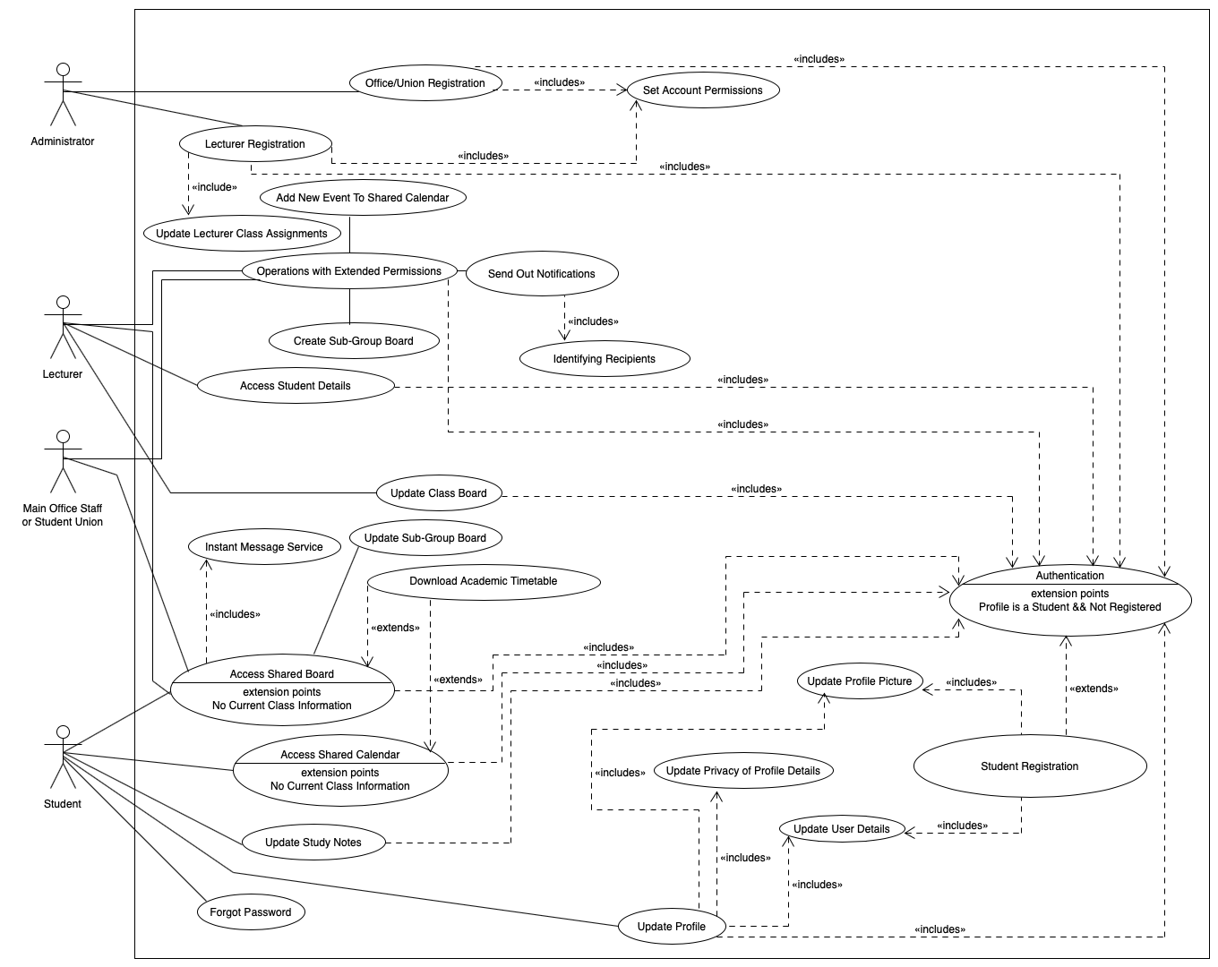
Figure 6: Use Case for System Requirements
Figure 6 is a graphical use case diagram which describes the functional system requirements listed in this section. This use case diagram shows how users interact with the higher education study planner and how individual components of the system interact with each other. Textual descriptions for each use case can be found in the appendix.

3.2 User Requirements Analysis

User requirements, which describe what the user expects the software to be able to do, will be gathered once development has started. These additional requirements will be gathered through a small focus group where users will be presented with the problem that this app is proposing to solve. Focus group participants will then be asked a series of questions which will include the following:
- Are there any additional features you would like to see included in this project?
- What do you see the limitations of this project being?
- Are there any additional problems you would like to see this project attempt to solve?
- What core features would you identify as being most critical to this project’s success? Additionally, what core features are least valuable to this project’s success?
- How would you judge whether this project is a success?

3.3 Challenges

The challenges in creating the systems that this project proposes will be both technical and logistical. The following section gives some examples of potential challenges.

3.3.1 Access to University Database

Universities currently store student data, including sensitive data, in a central database. Access to this database will be required in order to request a user’s academic timetable. The user’s timetable will then be stored on the local device. This database request needs to be done in a secure manner that avoids any and all sensitive data.

Accessing data that universities store on students poses a number of technical, logistical and ethical challenges:
- Each university will have its own data protection policy which needs to be adhered to. This policy may incur additional costs and restrictions on student data. Documented details on data usage and access will need to be created for the system administrator in charge of integrating the study planner into a university’s database.
- A single university’s database will also be large in size and scale. With multiple universities potentially using the study planner system at the same time, storing the volume of data requested from a single database on a local study planner database is unrealistic. A stable and secure connection will therefore need to be established and ensured on setup.
- Universities may also store data that the study planner needs to operate in an unexpected manner. Sufficient time needs to be taken to connect the study planner to a database containing the desired data, even if this database needs to be created from scratch.
- A separate sample copy of a higher education institutes database will be requested for use during development. This will help avoid malicious queries being sent in error to a institutes database during development which could cause data loss.

If a particular university is not able to give access to this data, some features will still be available to students who wish to use the system. Students will be able to manually enter their own timetable details and have access to a local calendar and file-board. These resources will not be shareable with anyone else. Students will also be able to set their own local notifications based on the data they enter. The study notes facilities described in Section 3.1 (FSR-8) and links to useful resources will also be available.

3.3.2 Storing Student Information

Data such as user passwords, application media, push notification certificates, and user timetables will all need to be stored on local device memory. There may not, however, be any available space on the local device in which to save this data. This project’s database will integrate with the available memory in order to reduce the weight on the local device where possible.

3.3.3 Compatibility with all Smartphone Types

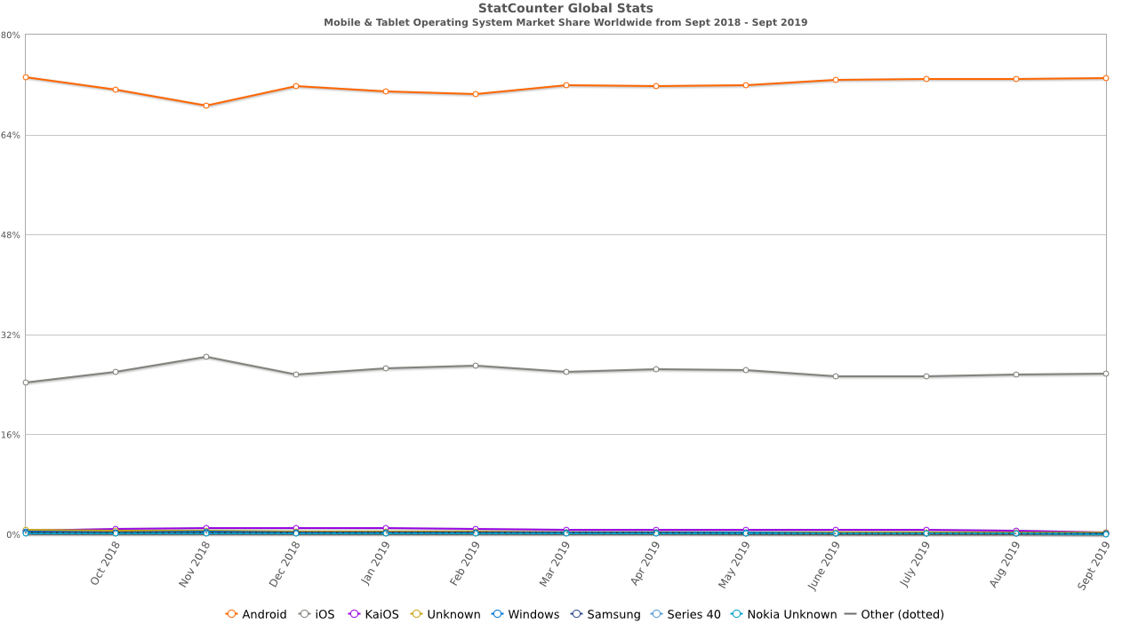
Figure 7: Mobile & Tablet Operating System Market Share Worldwide from Sept 2019 – Sept 2019, GlobalStats, 2019
As Figure 7 shows, the combined market shares of iOS and Android make up the majority of the mobile OS industry. There are, however, a number of other mobile OS platforms including KaiOS, Windows and Samsung. As this project’s mobile application is aimed at as wide a student user base as possible, development will also take into account these smaller mobile OS.

Some advanced components of newer iOS and Android versions may not be available to users running older versions or alternative mobile OS. Newer components will only be used in this project if the feature it is intended for does not fall within the core functionality. This will make sure all core features are available to all users.

4. Design

The development of this project will be completed solely by myself and I will pick a design methodology to reflect this. The design methodology that I will use to complete this project will resemble the agile development process. I will set realistic sprint deadlines and assign a moderate number of tasks to each sprint in order to balance development, requirements gathering and testing.

My initial planning for each sprint will change once user requirements have been gathered. During my initial planning I will leave enough time to take these changes into account. I will use Git, a free open source version control system, to track my work; plan sprints; open tasks and bug fixes; and log what additional development is needed.

4.1 MVC

The system architecture of this project will be designed using an MVC approach. This will allow the logic and testing to be equally divided between sprints and provide an organizational method for keeping the system code organized using version control.

The benefit of using an MVC architecture is that any modification to the mode of one component will not affect another. The scale of the project is also large and thus this architecture is ideal for keeping control over the essential behaviour and identifying what behaviour is not as important.
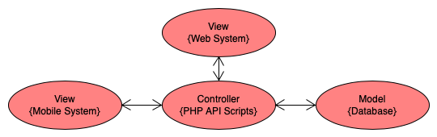
Figure 8: MVC

4.2 Initial Sketch of System Architecture

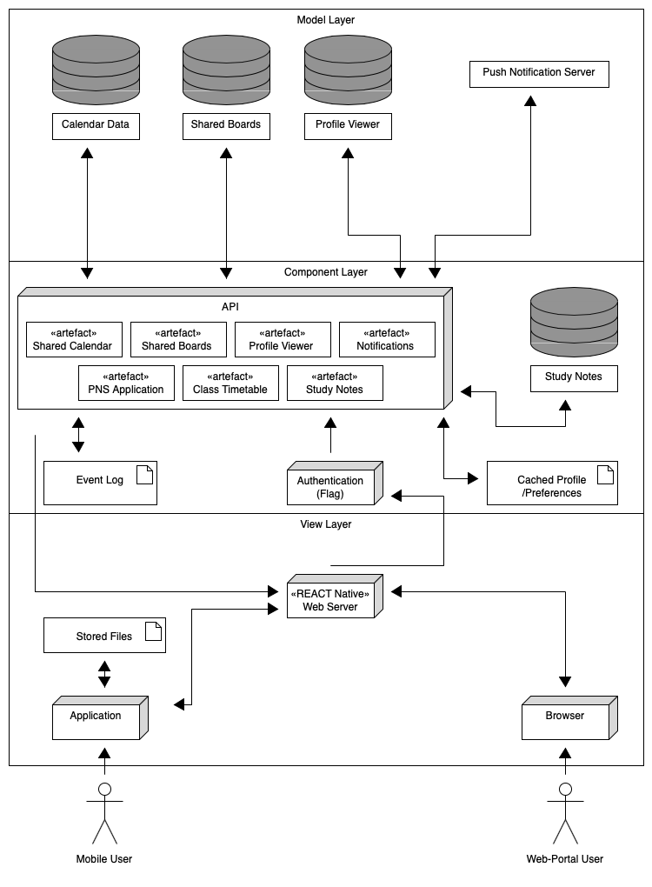
Figure 9: System Architecture
Figure 9 shows an initial sketch of the architecture for this project based upon a client-server architecture model. The client side of the architecture is represented by both of the applications, mobile and desktop, and the server side of the architecture is represented by a separate server which handles the processing. Details on the languages used to create individual components within the architecture are given in Section 4.3.

4.3 Architecture Languages

4.3.1 Mobile Implementation

The front-end view for the mobile study planner will be implemented using the REACT-Native framework for compatibility with both iOS and Android. The font-end will provide an initial framework to work with on future development as well as an intuitive UI for users to interact with.

The intermediary controller will be Implemented using PHP to facilitate HTTP POST requests between the front-end view and the database. The controller will protect against malicious attacks, such as SQL Injection and Cross Site Scripting, validate form data and handle cookies.

The database will be implemented in MySQL and will be used to store user data including user’s personal information, hashed password and local front-end settings. The database will be implemented in the relational database language MySQL because of its scalability and high performance.

4.3.2 Website Implementation

The front-end view for lecturer portal will be implemented using HTML5, CSS3 and Core-JS. This front-end view will facilitate user login, instant messaging services to students, update class calendars and share files on class sharing boards.

Additional scripts on the PHP controller will be added to facilitate the website’s integration into the existing back-end database and student application. Lecturer accounts will be marked with special permissions as their accounts will be able to access functions that students will not.

5. Evaluation Strategy

5.1 First Usability Evaluation

This project’s first usability evaluation will be conducted in a small closed environment. Participants will be split into two groups; the first group will evaluate the web-based portal and the second group will evaluate the mobile application. These groups will initially work independently to verify that the core functionality is working correctly. Some later tasks, as laid out below, will require interaction. Participants will primarily vary in technological skill, age, and role (roles include lecturers and students). All participants will be asked to sign a consent form prior to taking part in this evaluation. This usability evaluation will have the following aims:
- To determine whether the product produced meets the system requirements laid out in section 3.1.
- To determine whether the product produced meets the user requirements that will be gathered as described in section 3.2.
- To collect data, both qualitative and quantitative, that can inform further design decisions prior to the project’s deployment.
- To identify any issues or major bugs with the UX, usability or overall system

Participants will be told the purpose of both applications prior to this evaluation beginning. No explanation will be given on finding functionality as this forms part of this evaluation. Participants using the mobile application will be asked to complete the following initial tasks:
- To register an account using provided details
- To update the new profile with further provided details
- To upload a generic profile picture
- To log out, reset their password, and then log back in again
- To make some generic notes and test the organisational tools that are provided

At this stage users would normally need to register with classes by logging in to their higher educational institutes timetable system. For the purposes of this evaluation the participants registered accounts (including both web-based and mobile users) will be provided with generic classes, which will be added my myself, along with a generic academic timetable. Participants using the mobile application will then be asked to complete the following further tasks:
- To verify that events appear in the mobile app’s shared calendar
- To verify that files appear in the mobile app’s file boards
- To send a message to a web-based user
- To take their device offline and verify that their account’s academic timetable can be viewed through the device’s local storage
- To set some of the public details on the mobile account to private and ask the web-based user to verify what details are viewable
- To verify that notifications can be received

Participants using the web-based application will be asked to complete the following tasks using a pre-registered account:
- To add an event to a classes auto generated shared calendar
- To upload a provided file to a classes auto generated board
- To send a reply to a message
- The web-based user should send out a series of notifications to the mobile user individually, their class group and to everyone in their filtered list. The mobile user should check they have received all three notifications.

Some of the questions asked after these tasks have been completed will include what tasks took the most time to complete; what functions were the most difficult to find on the UI; how did you find the system’s usability; was anything about the system misleading; did you encounter any bugs? Additional questions will be added based upon the user requirements from Section 3.2 once these are gathered. Space will also be left for participants to leave comments.

5.2 Second Usability Evaluation

The second usability evaluation will be a more open public evaluation and involve testing of the mobile application only therefore this study will only involve students.

The primary participant in this study will be Heriot-Watt University however requests to other universities will be made. This study is a secondary opportunity to identifying any errors in functionality and therefore will not critically affect the core functionality of the system. If students participate in this evaluation, they will be invited to download the application through a public beta testing program. Participants will be asked to complete an online Google Form which will include questions on the user interface; the effectiveness of the application; and the systems performance and security. Analytics will also be gathered from the application while it is running on individual devices.

Participants consent will be gathered through the beta test software prior to the participant downloading the application. Consent will include the gathering of analytical data. A custom beta version of the application will be made available to participants based upon their university. This will include pre-setup links to necessary student data which will allow participants to log in to their own universities academic timetable server. These links will be added based upon the universities that accept the invitation to participate in the usability evaluation. When deployment occurs system administrators will need to associate a university with an existing data source which students associated with the university can access. Students will then, upon registration and verifying they are associated with this university, be able to access this data source.

If universities do not participate in this usability study, a general-purpose version of the application will be made available to any student in order to test non data reliant tools, including the study notes tools. Details on what tools are available to students who cannot login into a central university system are found in Section 3.3.1.

5.2.1 Automated Unit Testing

This usability evaluation will also use third-party libraries to generate automated unit tests. A log will be generated detailing what exceptions are encountered, what tests fail and the state of the system when tests fail. This data will be beneficial in diagnosing any bugs that users report. Consent for these tests will gathered prior to user participation in this evaluation.

6. Project Management

6.1 Timetable

Task | Start Date | End Date | Length (Days) | Action
1 | 25/11 | 09/12 | 14.00 | Begin Implementation of Mobile Application
2 | 03/12 | 04/12 | 1.00 | User Requirements Gathering
3 | 04/12 | 05/12 | 1.00 | Revise User Requirements
4 | 09/12 | 23/12 | 14.00 | Begin Implementation of Web-Portal
5 | 16/12 | 30/12 | 14.00 | Begin Implementation of Controller
6 | 23/12 | 06/12 | 14.00 | Begin Implementation of Model
7 | 06/01 | 10/01 | 4.00 | Integrate Components
8 | 10/01 | 24/01 | 14.00 | Debug
9 | 24/01 | 29/01 | 5.00 | Test in 1st Usability Evaluation
10 | 29/01 | 31/01 | 2.00 | Prepare Results from 1st Usability Evaluation
11 | 31/01 | 01/02 | 1.00 | Evaluate Results of 1st Usability Evaluation
12 | 01/02 | 06/02 | 5.00 | Implement Appropriate Changes From 1st Usability Evaluation Results
13 | 06/02 | 07/02 | 1.00 | Write Automated Tests
14 | 07/02 | 08/02 | 1.00 | Implement Analytics into App
15 | 08/02 | 09/02 | 1.00 | Write Google Form for 2nd Usability Evaluation
16 | 09/02 | 11/02 | 2.00 | Launch App in Public Beta for 2nd Usability Evaluation
17 | 11/02 | 12/02 | 1.00 | Promote 2nd Usability Evaluation
18 | 12/02 | 22/02 | 10.00 | Receive Responses To 2nd Usability Evaluation
19 | 22/02 | 23/02 | 1.00 | Evaluate Results of 2nd Usability Evaluation
20 | 23/02 | 28/02 | 5.00 | Implement Appropriate Changes From 2nd Usability Evaluation Results
21 | 28/02 | 01/03 | 1.00 | Verify Compliance with Apple App Store and Google Play Store

6.2 Gannt Chart

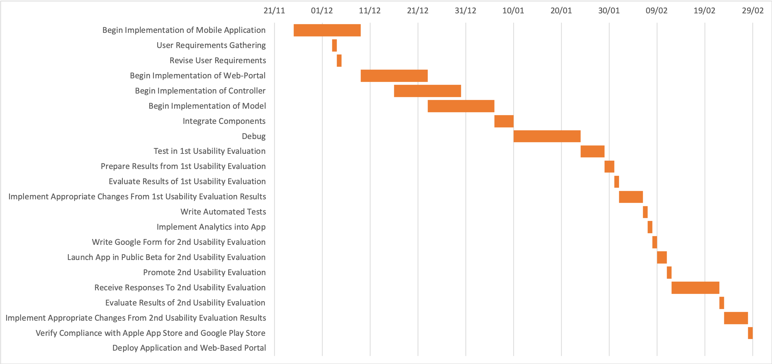

6.3 Analysis of Risks

ID | Risk | Description | Severity | Mitigation Plan
1 | Loss of data | Data may become corrupt or accidently deleted. | Major | Data won’t be stored in one location. I will ensure data is stored in several locations such as GitHub, hard disks, and USBs.
2 | Acquiring new skills | Time may be required to learn new skills e.g. new programming languages. | Minor | I will ensure I have ample time to learn new skills. This may require extra hours of work however this will ensure the end product is completed on time.
3 | Data is not stored securely | User data is not properly stored and leads to hackers obtaining it. | Major | All secure data will be encrypted and stored separately from encryption keys.
4 | Requirements gathered are ambiguous. | Requirements aren’t concise and are open to developer interpretation. | Minor | I will ensure that requirements are to the point during requirements gathering. I will make sure I am clear what issues are being tackled and ensure clarity on all requirements throughout the development process.
5 | End User Expectations are not met | The user expects to receive something different compared to the project applications. | Severe | I will check with the intended end users that the application is meeting their expectations during development. I will ensure that they know what the system requirements are and that they agree with them during the user requirements gathering session.
6 | Unforeseen requirements | Requirements are missed before the end of the project. | Moderate | I will update the project requirements and ensure all documentation is correct in relation to the updated requirements. I will ensure that any component that relates to a changed requirement is redone and that any new requirement features are implemented.
7 | Underestimating the project size. | The project is oversimplified during the design stage. | Major | I will ensure requirements are prepared properly and that every requirement that is a ‘must have’ is completed. The complexity of this project will be thoroughly understood before development begins.
8 | Risk of unsustainable user growth. | The project is successfully deployed however the traffic on the system grows faster than expected. | Major | I will utilise bulk actions, create automated services within the app to reduce manual oversight, and create a system support page via a FAQ website.
9 | Risk of app being denied. | The app is denied deployment into Google Play or Apple App Store. | Moderate | I will research the rules of each app store during a sprint. I will make sure all rules are adhered to before deployment.
10 | Risk of only developing for a single platform. | A supported platform for deployment disappears that greatly reduces support base. | Minor | Android and iOS make up over 90% of mobile operating system market share therefore these platforms must take priority over all others as they make up the largest user base.
11 | Risk of cyber attacks | The code has a vulnerability that causes bugs or viruses to get into client’s systems or data is returned that should have been secure. | Moderate | I will manage exposure of data to client views through controller. Data will be checked before being allowed to be download to user accounts. No data will be downloaded to user file systems other than txt or pdf documents.
12 | Third party library licences are not adhered to | No deceleration of third-party licences used in this project is given. | Minor | I will make sure licence files are included in the final code base and that appropriate references are made within the source code.
13 | Student data is not available (Section 3.3.1) | University does not have a single location for accessing student data | Moderate | Only allow access to core features including study notes tools, external links, and a person calendar and file board (Section 3.3.1 paragraph 3). Lock access to data specific functions e.g. class tools.
14 | Student data is not kept up to date (Section 3.3.1) | University does not keep their data source on student’s up to date | Minor | I will include contact details for the system administrators of the local university so that requests for updates can be made
15 | Student data access is revoked (Section 3.3.1) | University revokes the apps access to data | Major | Data associated with students will be deleted. Functions that require student data will also be locked from being accessed until student data is restored.
16 | External student data loss (Section 3.3.1) | University loses student data source | Major | Data on local study planner system should be maintained in such a way that most functions that are reliant on this data can remain functional. Functions that, as a result, cannot function should be locked from access until the data is available again.

6.4 Considerations of Professional, Legal, Ethical, and Social Issues

Software, including third party libraries, will only be used if it is open source, if a free student licence has been obtained, or if a bought licence has been obtained. All code, particularly in regard to code that is open source, will be appropriately accredited. Where this project is deployed to a particular mobile application store, the relevant codes of conduct will also be complied with.

This project’s usability evaluations and requirements gathering studies will be carried out in an ethical manner. Participants in studies or evaluation will be made aware of any risks, how their data will be used, and that they can stop at any time. Participants will be recruited via posters placed around Heriot-Watt, through targeted email requests within Heriot-Watt or other university institutions, and via face to face requests to students and lecturers at Heriot-Watt. No participants will be under the age of 16.

All data (including from usability tests; requirements tests; and models of the applications) is collected under GDPR rules. None of the data collected from usability or requirements tests will be stored in a manner that can be traced back to the original participant. Personal data collected to create accounts will be kept for no longer that is necessary for the purpose of keeping the account open and can be deleted at any time at the request of the account holder. All virtual data will be kept encrypted with password protection. A privacy policy and terms of use will need to be accepted prior to registration to maintain compliance with GDPR and allow access to the Data Controller’s personal details.

A. References

Harte, R., Glynn, L., Rodríguez-Molinero, A., Baker, P.M., Scharf, T., Quinlan, L.R. and ÓLaighin, G., 2017. A human-centered design methodology to enhance the usability, human factors, and user experience of connected health systems: a three-phase methodology. JMIR human factors, 4(1), p.e8.

Peters, K., 2005. Learning on the move: Mobile technologies in business and education. Flexible Learning Advisory Group.

Dahlstrom, E., Walker, J.D. and Dziuban, C., 2013. ECAR study of undergraduate students and information technology (p. 2013). 2013.

Seilhamer, R., Chen, B., Sugar, A., Berge, Z.L. and Muilenburg, L.Y., 2013. A framework for implementing mobile technology. Handbook of mobile learning, pp.382-394.

Martin, F., 2008. Blackboard as the learning management system of a computer literacy course. Journal of Online Learning and Teaching, 4(2), pp.138-145.

Machado, M. and Tao, E., 2007, October. Blackboard vs. Moodle: Comparing user experience of learning management systems. In 2007 37th annual frontiers in education conference-global engineering: Knowledge without borders, opportunities without passports (pp. S4J-7). IEEE.

Hall, J. (2003). Assessing Learning Management Systems. Retrieved August 26, from
http://www.clomedia.com/content/templates/clo_feature.asp?articleid=91&zoneid=29

Green, L.S. and DENTON, B., 2012. Examination of factors impacting student satisfaction with a new learning management system. Turkish Online Journal of Distance Education, 13(3), pp.189-197.

Bradford, P., Porciello, M., Balkon, N. and Backus, D., 2007. The Blackboard learning system: The be all and end all in educational instruction?. Journal of Educational Technology Systems, 35(3), pp.301-314.

Collabro., 2017. ‎myHWU. online, <https://apps.apple.com/gb/app/myhwu/id1260559655>, accessed 10 October 2019.

University of Glasgow., 2019. ‎Timetable & Room Finder. online. <https://apps.apple.com/us/app/timetable-room-finder/id1479855374>, accessed 11 October 2019.

Chen, B. and Denoyelles, A., 2013. Exploring students’ mobile learning practices in higher education. Educause Review, 7.

Chen, B. and Denoyelles, A., 2013. Device ownership (N=1,082). digital image. Educause. viewed 11 October 2019. <https://er.educause.edu/-/media/images/articles/2013/10/chen_figure1.jpg?la=en&hash=3F590B0D38DA4D6EDFA84DE5F81ACBCAB4BED32F>.

Chen, B. and Denoyelles, A., 2013. Comparing ownership and use for academic purposes (N-1,082). digital image. Educause. viewed 11 October 2019, <https://er.educause.edu/-/media/images/articles/2013/10/chen_figure2.jpg?la=en&hash=8CAE27A5043E9D1044555DCEA0A42CDEB8E721C9>.

Ma, Z., Wang, H., Guo, Y. and Chen, X., 2016, May. LibRadar: fast and accurate detection of third-party libraries in Android apps. In Proceedings of the 38th international conference on software engineering companion (pp. 653-656). ACM.

Raemaekers, S., van Deursen, A. and Visser, J., 2012, March. An analysis of dependence on third-party libraries in open source and proprietary systems. In Sixth International Workshop on Software Quality and Maintainability, SQM (Vol. 12, pp. 64-67).

Haefliger, S., Von Krogh, G. and Spaeth, S., 2008. Code reuse in open source software. Management science, 54(1), pp.180-193.

invertase., 2019. ‎react-native-firebase. online. available at: <https://github.com/invertase/react-native-firebase>. accessed 10 October 2019.

Li, N., Du, Y. and Chen, G., 2013, December. Survey of cloud messaging push notification service. In 2013 International Conference on Information Science and Cloud Computing Companion (pp. 273-279). IEEE.

Guo, W. and Liu, H., 2013, August. The analysis of push technology based on iphone operating system. In Proceedings of 2013 2nd International Conference on Measurement, Information and Control (Vol. 1, pp. 570-574). IEEE.

Cooijmans, T., de Ruiter, J. and Poll, E., 2014, November. Analysis of secure key storage solutions on Android. In Proceedings of the 4th ACM Workshop on Security and Privacy in Smartphones & Mobile Devices (pp. 11-20). ACM.

Gong, J. and Tarasewich, P., 2004, November. Guidelines for handheld mobile device interface design. In Proceedings of DSI 2004 Annual Meeting (pp. 3751-3756).

oblador., 2019. ‎react-native-keychain. online. available at: <https://github.com/oblador/react-native-keychain>. accessed 11 October 2019.

GlobalStats. 2019. Mobile & Tablet Operating System Market Share Worldwide from Sept 2019 – Sept 2019. digital image. Stat Counter. viewed 29 October 2019, <https://gs.statcounter.com/os-market-share/mobile-tablet/worldwide/#monthly-201809-201909>.

B. Figures

Figure 2. Comparing ownership and use for academic purposes (N=1,082), Chen et al, 2013 9
Figure 1 Device Ownership (N=1,082), Chen et al, 2013 9
Figure 3: Token System for Push Requests 12
Figure 5: myHWU (Collabro, 2017) 15
Figure 4: Timetable & Room Finder (University of Glasgow, 2019) 15
Figure 6: Use Case for System Requirements 19
Figure 7: Mobile & Tablet Operating System Market Share Worldwide from Sept 2019 – Sept 2019, GlobalStats, 2019 22
Figure 8: MVC 23
Figure 9: System Architecture 24

C. Appendix

1. Textual Use Case Descriptions

Use Case ID | 1
Use Case | Forgot Password
Description | User requests a password reset
Primary Actors | Heriot-Watt Student
Preconditions | - Student has an Account
Main Flow | - The user opens the mobile app  - The user clicks on the password forgotten button  - The user enters their registered e-mail  - The user opens the link in the email sent to their inbox  - The user enters a new password and retypes to confirm
Post Conditions | - The user has a new password to login to authenticate with

Use Case ID | 2
Use Case | Update Study Notes
Description | User updates their stored study notes
Primary Actors | Heriot-Watt Student
Preconditions | - Include (Authentication)  - The user has opened the notes tab
Main Flow | - The user scrolls through their notes  - The user edits the note they want to change  - The user reorganises their notes
Post Conditions | - The user’s notes have been updated and saved

Use Case ID | 3
Use Case | Access Shared Boards
Description | User accesses a shared study/sub-group board
Primary Actors | Heriot-Watt Student, Lecturer, Main Office Staff or Student Union
Preconditions | - Include (Authentication)  - User is on the shared board tab
Main Flow | - The user selects the board they wish to access  - Include (Instant Message Service)
Alternative Flow | No Current Class Information

Use Case ID | 4
Use Case | Access Shared Calendar
Description | User view events in a shared calendar
Primary Actors | Heriot-Watt Student
Preconditions | - Include (Authentication)  - User is on the calendar tab
Main Flow | - The user selects the calendar they want to view  - The user selects the day of the calendar they want to view
Alternative Flow | No Current Class Information

Alternative Flow ID | 3.1/4.1
Use Case | No Current Class Timetable Information
Description | Details on Student’s Classes Are Not Available
Primary Actors | Heriot-Watt Student
Preconditions | - Include (Authentication)  - Timetable was not found on local storage
Main Flow | - Log in to timetable server (Section 3.3.1)  - Retrieve data  - Store locally  - Return to Step 2 of preconditions in sender

Use Case ID | 5
Use Case | Authentication
Description | Log in email and password are verified
Primary Actors | Heriot-Watt Student, Main Office Staff, Lecturer, Administrator
Main Flow | - User has opened portal or application  - User has entered their registered email address  - User has entered their registered password
Post Conditions | - Authentication successful  - User details retrieved
Alternative Flow | Profile is a Student && Not Registered

Alternative Flow ID | 5.1
Use Case | Profile is a Student && Not Registered
Description | Student Has Failed to Log in Multiple Times in A Row
Primary Actors | Heriot-Watt Student
Preconditions | - Log in email user attempted to use to access an account is not registered
Main Flow | - User clicks on link to register  - Include (Register)

Use Case ID | 6
Use Case | Register
Description | New Registration with System
Primary Actors | Heriot-Watt Student
Main Flow | - Student opens mobile application  - Student selects registration button  - Include (Update User Details)  - Include (Update Profile Picture)
Post Conditions | - New profile created

Use Case ID | 7
Use Case | Update Profile
Description | Update a Registered Profile with New Details
Primary Actors | Heriot-Watt Student
Preconditions | - Include (Authentication)
Main Flow | - Include (Update Profile Picture)  - Include (Update User Details)  - Include (Update Privacy of Profile Details)
Post Conditions | - New Account Created

Use Case ID | 8
Use Case | Instant Message Service
Description | Student send message to organiser of board
Primary Actors | Heriot-Watt Student, Lecturer, Main Office Staff or Student Union
Preconditions | - Include (Authentication)  - User Is in messaging screen in a shared board
Main Flow | - User enters intended recipients name  - Name verified as available within shared board  - User writes message  - User Presses Send
Post Conditions | - Message is received on recipients account

Use Case ID | 9
Use Case | Update sub-group board
Description | Upload of a post onto a sub-group board
Primary Actors | Student, Lecturer, Main Office Staff or Student Union
Preconditions | - Include (Authentication)  - User on shared boards tab  - User has selected a board that is not a class board
Main Flow | - User selects add a new post  - User uploads any relevant files into location in board’s directory  - User adds some text describing post  - User presses post
Post Conditions | - Successful upload of post  - Any uploaded data stored successfully

Use Case ID | 10
Use Case | Update Profile Picture
Description | Update the Profile Picture stored on file
Primary Actors | Student
Preconditions | - Include (Authentication)  - User on the update profile screen
Main Flow | - User presses profile picture upload button  - User selects a file which is a valid image type  - File is uploaded and changed on screen
Post Conditions | - New profile picture successfully updated, and data stored

Use Case ID | 11
Use Case | Update Privacy of Profile Details
Description | Update privacy of user’s details that are stored on file
Primary Actors | Student
Preconditions | - Include (Authentication)  - User on the update profile screen
Main Flow | - User selects privacy dropdown next to relevant data  - User updates privacy to their preferred choice
Post Conditions | - New privacy settings successfully updated

Use Case ID | 12
Use Case | Update User Details
Description | Update a user’s details that are stored on file
Primary Actors | Student
Preconditions | - Include (Authentication)  - User on the update profile screen
Main Flow | - User edits the text box containing info they want to change  - User presses save
Post Conditions | - New details successfully updated, and data stored

Use Case ID | 13
Use Case | Update Class Board
Description | Upload a post onto a class board
Primary Actors | Lecturer
Preconditions | - Include (Authentication)  - User is on shared boards tab
Main Flow | - User selects add a new post  - User uploads any relevant files into location in board’s directory  - User adds some text describing post  - User presses post
Post Conditions | - Successful upload of post  - Any uploaded data stored successfully

Use Case ID | 14
Use Case | Access Student Details
Description | Access public details on a student
Primary Actors | Lecturer
Preconditions | - Include (Authentication)  - User is on profile viewer
Main Flow | - User types in relevant user’s name  - User selects profile
Post Conditions | - Public profile details of selected user appear on screen

Use Case ID | 15
Use Case | Create Sub-Group Board
Description | Create a sub-group board for a select group
Primary Actors | Lecturer, Main Office Staff or Student Union
Preconditions | - Include (Authentication)  - User is on shared board tab
Main Flow | - User selects create new board button  - User creates enters their board name  - User enters their intended recipients/group
Post Conditions | - Board successfully created

Use Case ID | 16
Use Case | Send Out Notifications
Description | Send out a notification to a filtered group of recipients
Primary Actors | Lecturer, Main Office Staff or Student Union
Preconditions | - Include (Authentication)  - User is on notification page
Main Flow | - User enters message  - User adds optional media files  - Include (Identifying Recipients)  - User presses send
Post Conditions | - Recipients receive notification

Use Case ID | 17
Use Case | Identifying Recipients
Description | Identify the recipients who will receive a push notification
Primary Actors | Lecturer, Main Office Staff or Student Union
Preconditions | - Include (Authentication)  - Notification is being prepared
Main Flow | - Users are searched for by name  - Filters are applied through bar next to search bar

Use Case ID | 18
Use Case | Add New Event to Shared Calendar
Description | Add a new event to a calendar which is shared with multiple recipients
Primary Actors | Lecturer, Main Office Staff or Student Union
Preconditions | - Include (Authentication)  - User is on shared calendar tab
Main Flow | - User opens relevant calendar  - User selects add new event button  - User adds title of event  - User adds deadline  - User adds priority  - User presses add
Post Conditions | - New event added to shared calendar  - All members of shared calendar can view event

Use Case ID | 19
Use Case | Lecturer Registration
Description | Create a lecturer account that has extended permissions
Primary Actors | Administrator
Preconditions | Include (Authentication)
Main Flow | - Administrator opens lecturer registration page  - Include (Set Account Permissions)  - Include (Update Lecturer Class Assignments)
Post Conditions | - New lecturer profile created

Use Case ID | 20
Use Case | Update Lecturer Class Assignments
Description | Add lecturer class assignments to an account
Primary Actors | Administrator
Preconditions | - Include (Authentication)
Main Flow | - Search for existing class  - Class selected or option for adding new class  - Class details are verified  - Administrator presses add
Post Conditions | - New class added to lecturer profile  - Board and shared calendar created for class

Use Case ID | 21
Use Case | Set Account Permissions
Description | Set relevant extended permissions to an account
Primary Actors | Administrator
Preconditions | Include (Authentication)
Main Flow | - Permission levels selected using a dropdown menu next to an account function  - Repeat step 1 for each individual account function
Post Conditions | - New class added to lecturer profile

Use Case ID | 22
Use Case | Office/Student Union Registration
Description | Create an office/union registration account that has extended permissions
Primary Actors | Administrator
Preconditions | - Include (Authentication)
Main Flow | - Administrator opens office/union registration page  - Include (Set Account Permissions)
Post Conditions | - New office/union profile created

